SELECT timestampdiff(year,'2013-05-12',now());

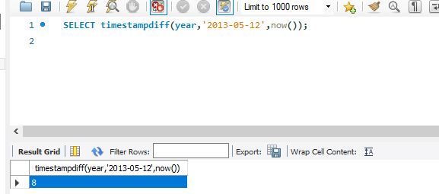

SELECT timestampdiff(month,'2013-05-12',now());

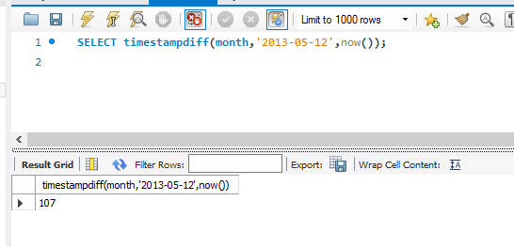

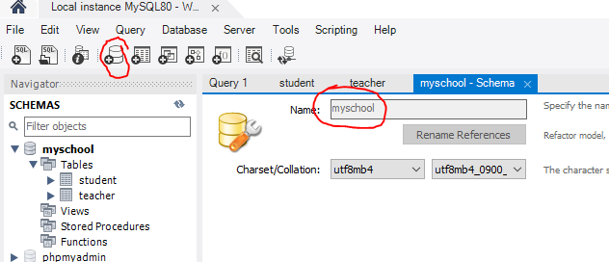

CREATE TABLE `student` (

`id` char(10) NOT NULL,

`firstname` varchar(45) NOT NULL,

`lastname` varchar(70) NOT NULL,

`email` varchar(200) DEFAULT NULL,

`birthday` date NOT NULL,

PRIMARY KEY (`id`)

) ;

INSERT INTO `student` VALUES ('6020000010','ดวงดาว','สุกสว่าง',NULL,'1980-07-31'),('6220000001','มานี','แสงดาว','manee@gmail.com','1990-04-15'),('6220000020','ปิติ','ดรุณศึกษา','darun_piti@hotmail.com','1980-07-31'),('6220000030','ชูใจ','ลูกใครแน่',NULL,'1995-12-25'),('6220000040','มานะ','แสงดาว',NULL,'1990-04-15');

CREATE TABLE `teacher` (

`id` int NOT NULL AUTO_INCREMENT,

`firstname` varchar(45) NOT NULL,

`lastname` varchar(70) NOT NULL,

`email` varchar(200) DEFAULT NULL,

PRIMARY KEY (`id`)

);

INSERT INTO `teacher` VALUES (1,'ฐิติรัตน์','ศิริบวรรัตนกุล','thitirat@as.nida.ac.th'),(4,'ธนชาติ','ฤทธิ์บำรุง',NULL),(5,'ธนาสัย','สุคนธ์พันธุ์',NULL),(6,'อัลบัส','ดัมเบิลดอร์',NULL),(7,'เซเวอรัส','สเนป',NULL),(8,'วรพล','พงค์เพชร','worapol@as.nida.ac.th');

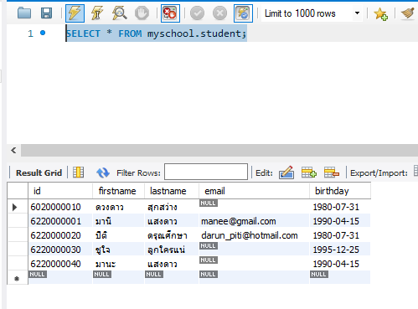

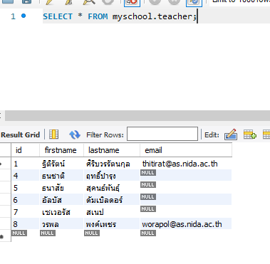

Query

SELECT firstname,lastname

FROM teacher;

|  |  |
| --- | --- |
| ฐิติรัตน์ | ศิริบวรรัตนกุล |
| ธนชาติ | ฤทธิ์บำรุง |
| ธนาสัย | สุคนธ์พันธุ์ |
| อัลบัส | ดัมเบิลดอร์ |
| เซเวอรัส | สเนป |
| วรพล | พงค์เพชร |

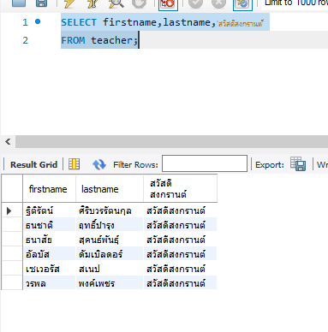

คำนวณอายุ

SELECT id ,

firstname,

lastname, timestampdiff(year,birthday,NOW()) AS age

FROM student;

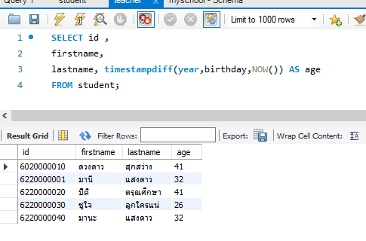

SELECT *

FROM student

WHERE(birthday>='1985-01-01') AND (id<'6220000030');

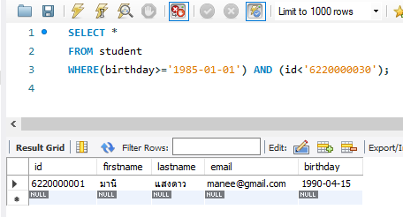

SELECT id , firstname

FROM student

WHERE email IS NOT NULL;

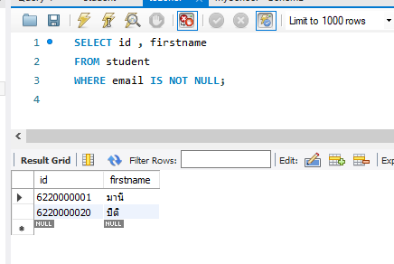

SELECT id ,

firstname,

lastname, timestampdiff(year,birthday,NOW()) AS age

FROM student

WHERE firstname ='มานี' OR firstname='ชูใจ';

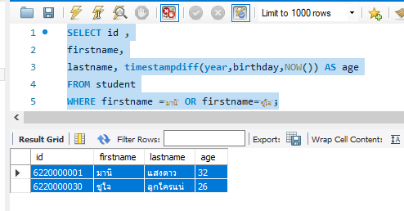

SELECT *

FROM teacher

WHERE firstname LIKE 'ธ%'; ชื่อขึ้นต้นด้วย ธ

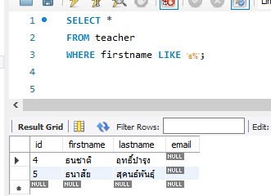

SELECT *

FROM teacher

WHERE firstname LIKE '%ส';

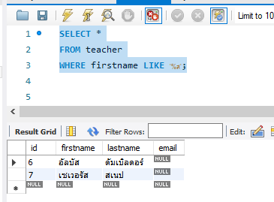

SELECT *

FROM teacher

WHERE firstname LIKE '_____ส'; unserscore _ _ _ _ _ ส



SELECT *

FROM teacher

WHERE firstname REGEXP 'ธน|ัส|ฐ';

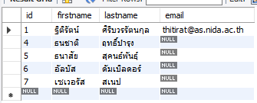

SELECT *

FROM teacher

WHERE firstname REGEXP '^ธ|ส$';

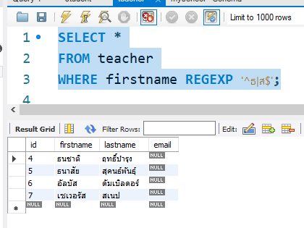

SELECT *

FROM student

order by birthday DESC;

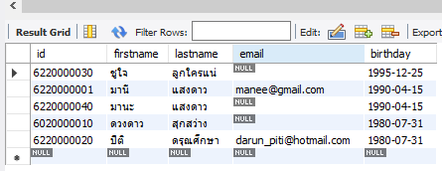

SELECT *

FROM student

ORDER BY birthday DESC , id ; 1.เรียงวันเกิด มากไปน้อย (มากคือเกิดทีหลัง)2. ID เรียงน้อยไปมาก

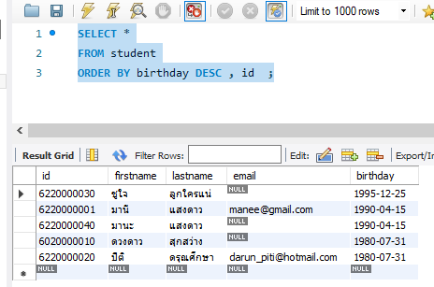

ใช้ LIMIT จำกัดการแสดงผล

SELECT *

FROM student

ORDER BY birthday DESC , id

LIMIT 3;

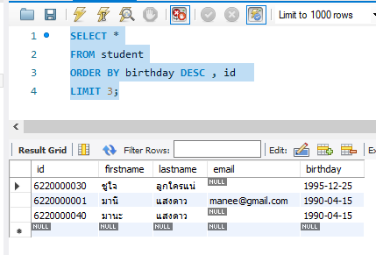

เขียนเป็นเลขคอลัมน์แทนก็ได้

SELECT *

FROM student

ORDER BY 5 DESC , 1

LIMIT 3;

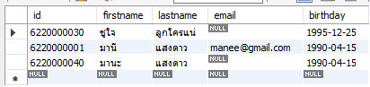

SELECT id ,

firstname,

lastname, timestampdiff(year,birthday,NOW()) AS age

FROM student

ORDER BY age*10 DESC; --เรียงลำดับด้วยผลทางคณิต

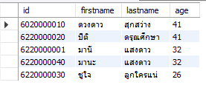

SELECT *

FROM student

GROUP BY birthday;

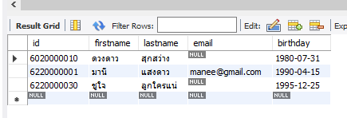

SELECT * FROM student

GROUP BY birthday,email;

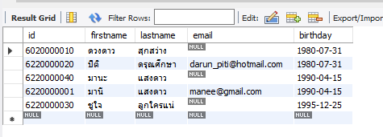

SELECT * FROM student

GROUP BY birthday,lastname; --มานี มานะซ้ำกัน

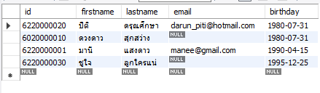

SELECT MAX(birthday)

FROM Student;

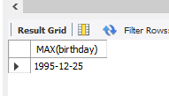

SELECT firstname , lastname,MAX(birthday)

FROM Student;

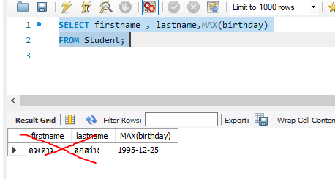

SELECT firstname , lastname

FROM Student

WHERE birthday=MAX(birthday);

Error



การใช้ Having คู่กับ Group by

SELECT

birthday,COUNT(birthday) AS n

FROM Student

GROUP BY Birthday

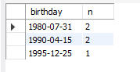

SELECT

birthday,COUNT(birthday) AS n

FROM Student

GROUP BY Birthday

HAVING n>1;



SELECT *

FROM student

GROUP BY birthday

HAVING birthday = MAX(birthday);

ผลลัพธ์ไม่ตรง

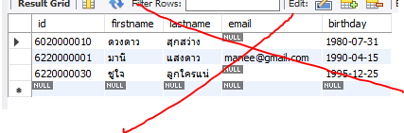

วิธีเรียงแล้วใช้ Limit 1

SELECT * FROM Student

ORDER BY Birthday DESC LIMIT 1;

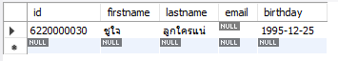

ใช้ sub query

SELECT firstname ,lastname, timestampdiff(year,birthday,now()) AS age

FROM student

WHERE birthday = (SELECT MAX(birthday) FROM student);



SELECT firstname ,lastname, timestampdiff(year,birthday,now()) AS age

FROM student

WHERE birthday = (SELECT MIN(birthday) FROM student);



SELECT id

FROM teacher

WHERE firstname regexp'^ฐ';



แก้ไข import script error

ปลี่ยน DEFAULT CHARSET=utf8 COLLATE=utf8_general_ci;

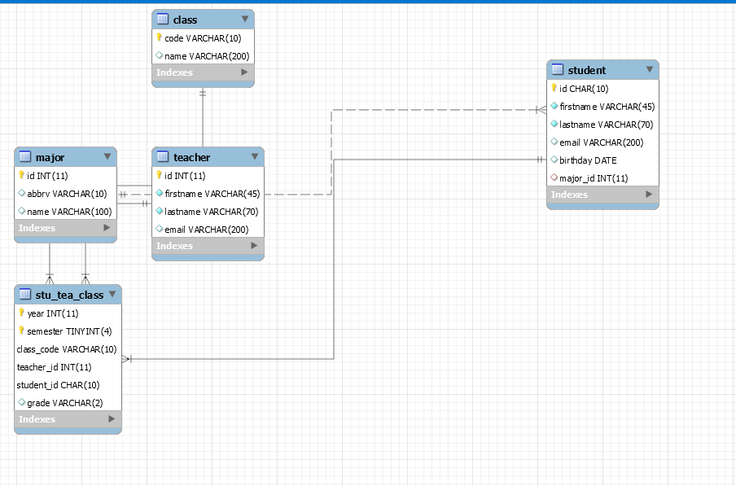

SELECT *

FROM stu_tea_class AS stc

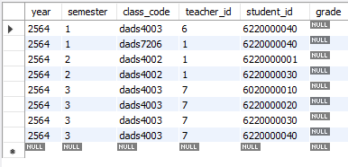

--แสดงชื่อ ทุกคนที่ขึ้นต้นด้วย ฐ

SELECT *

FROM stu_tea_class AS stc

WHERE stc.teacher_id IN (SELECT id FROM teacher WHERE firstname REGEXP'^ฐ')

ORDER BY stc.year , stc.semester ,stc.class_code;

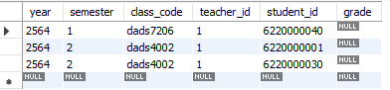

SELECT

stc.year,

stc.semester,

stc.class_code,

c.name AS class_name,

stc.teacher_id,

stc.student_id,

stc.grade

FROM stu_tea_class AS stc

JOIN class AS c

ON stc.class_code = c.code

ORDER BY 'year' , semester , class_code;

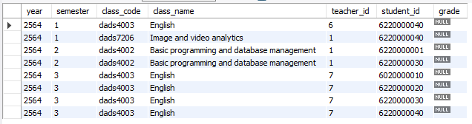

SELECT

stc.year,

stc.semester,

stc.class_code,

c.name AS class_name,

CONCAT(t.firstname,'',t.lastname) AS teacher_name ,

stc.student_id,

stc.grade

FROM stu_tea_class AS stc

JOIN class AS c

ON stc.class_code = c.code

JOIN teacher AS t

ON stc.teacher_id =t.id

ORDER BY 'year' , semester , class_code;

